Name:- Atharva Salitri
Roll No:- 29
Division: TY CSAI-B
Batch:- 2
PRN:- 12310120
Subject:- Cloud Computing

Assignment 1

Problem Statement:- To install an OS using VirtualBox/ VMWare Workstation. Add Storage to create new virtual disk.

- Creating Virtual machine in VMWare:

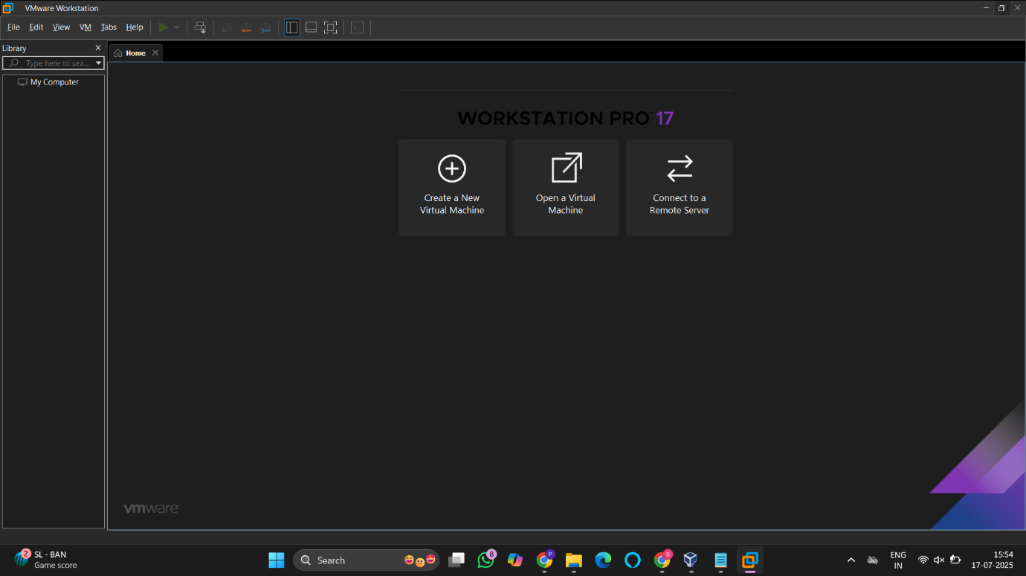
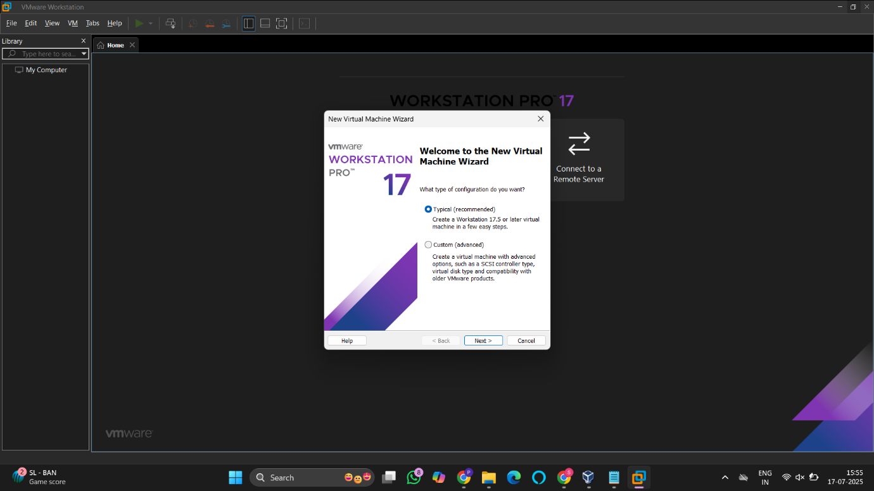

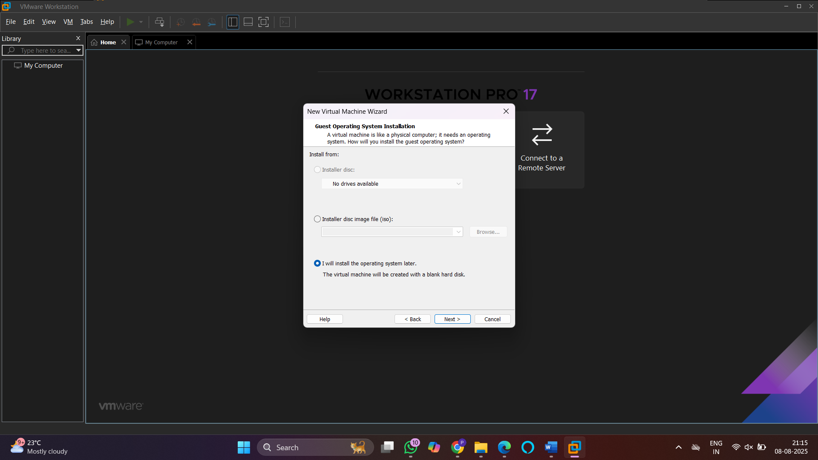
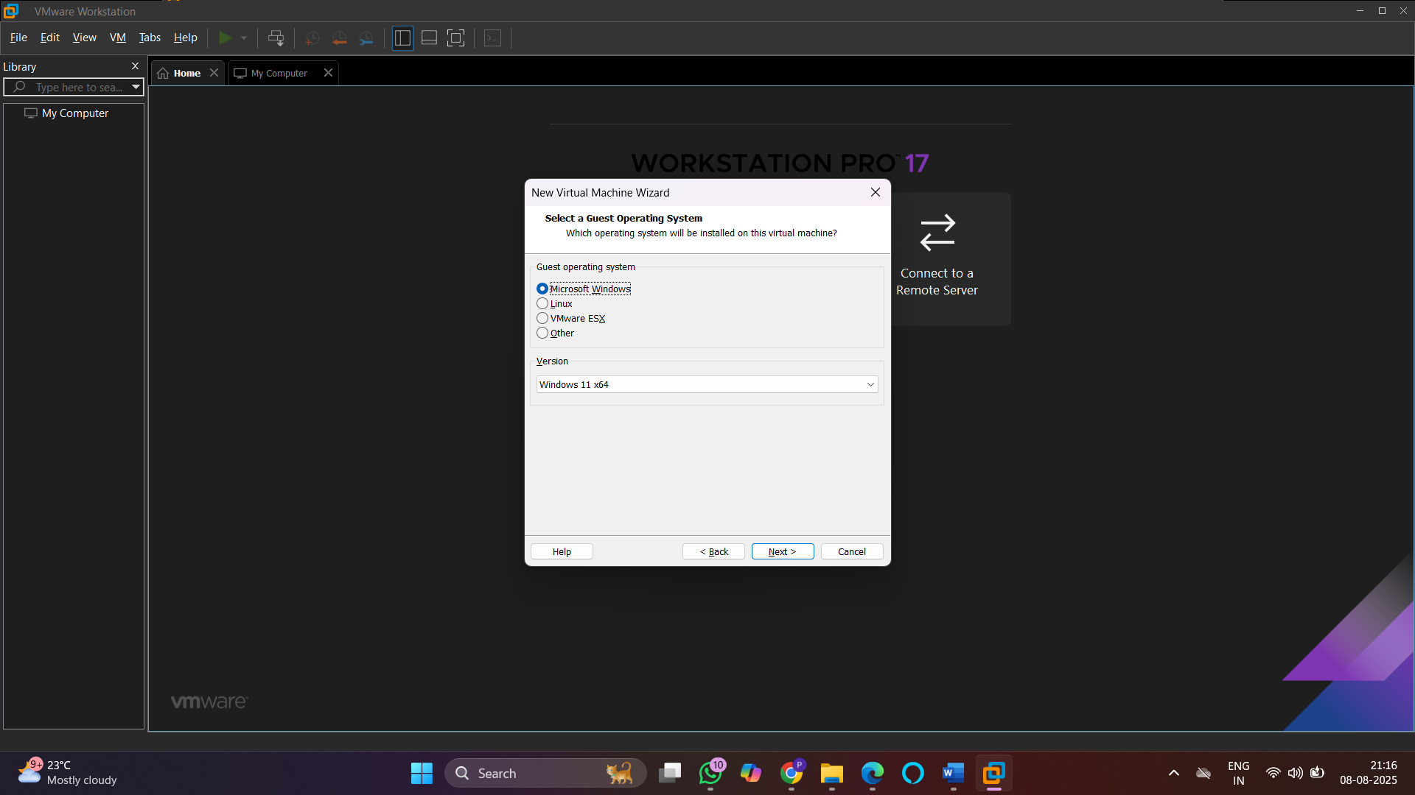
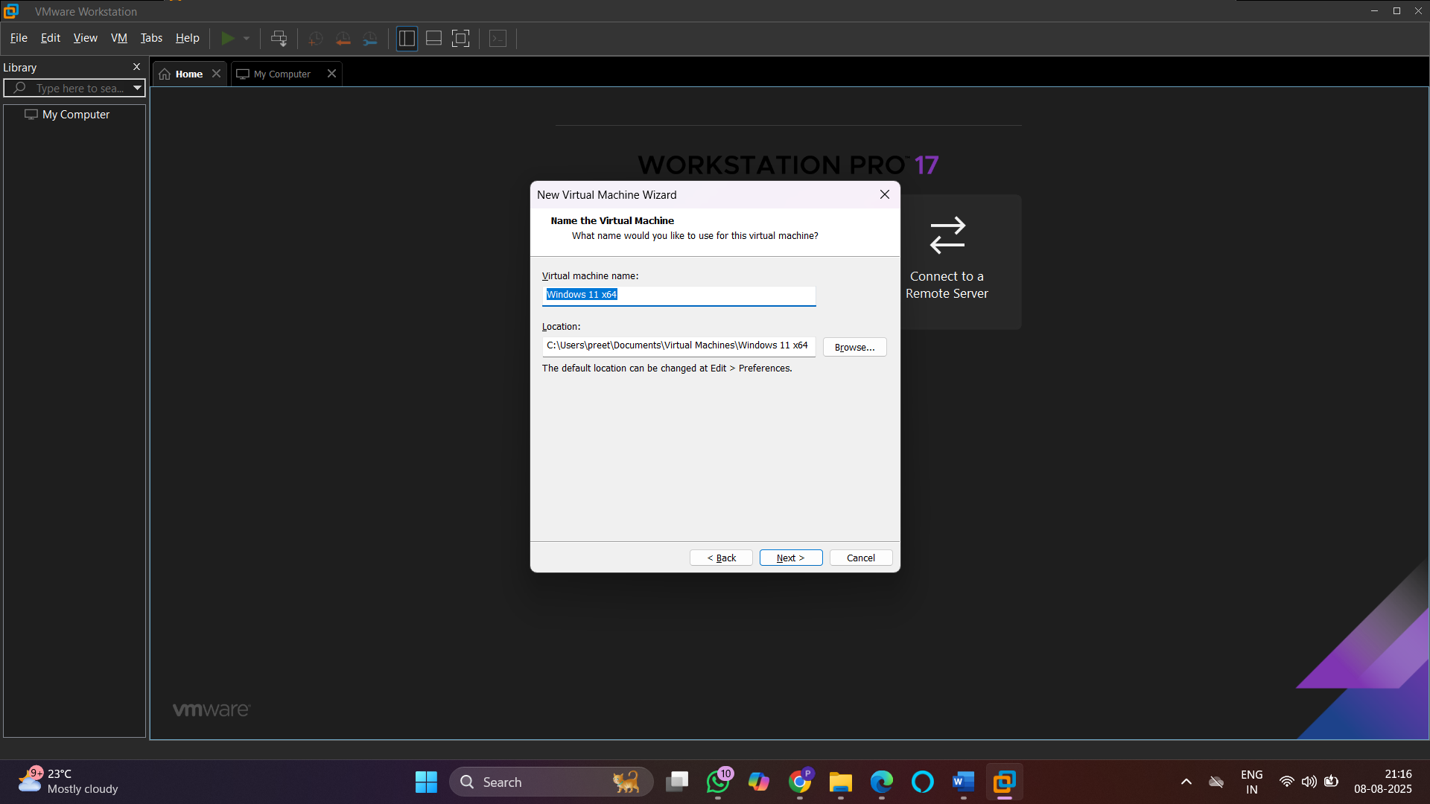

- Creating Virtual machine in Virtual Box:

- INSTALLATION STEPS :-

- Download oracle virtual box from https://www.virtualbox.org/wiki/Downloads . Click on
“ Windows hosts “ under VirtualBox 7.0.18 platform packages.

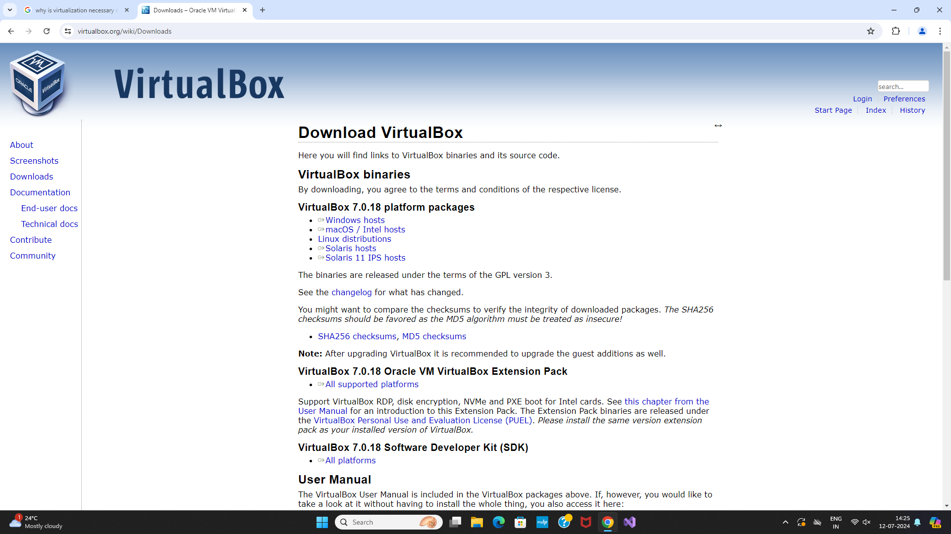

- After downloading the virtualbox.exe file , Install it.
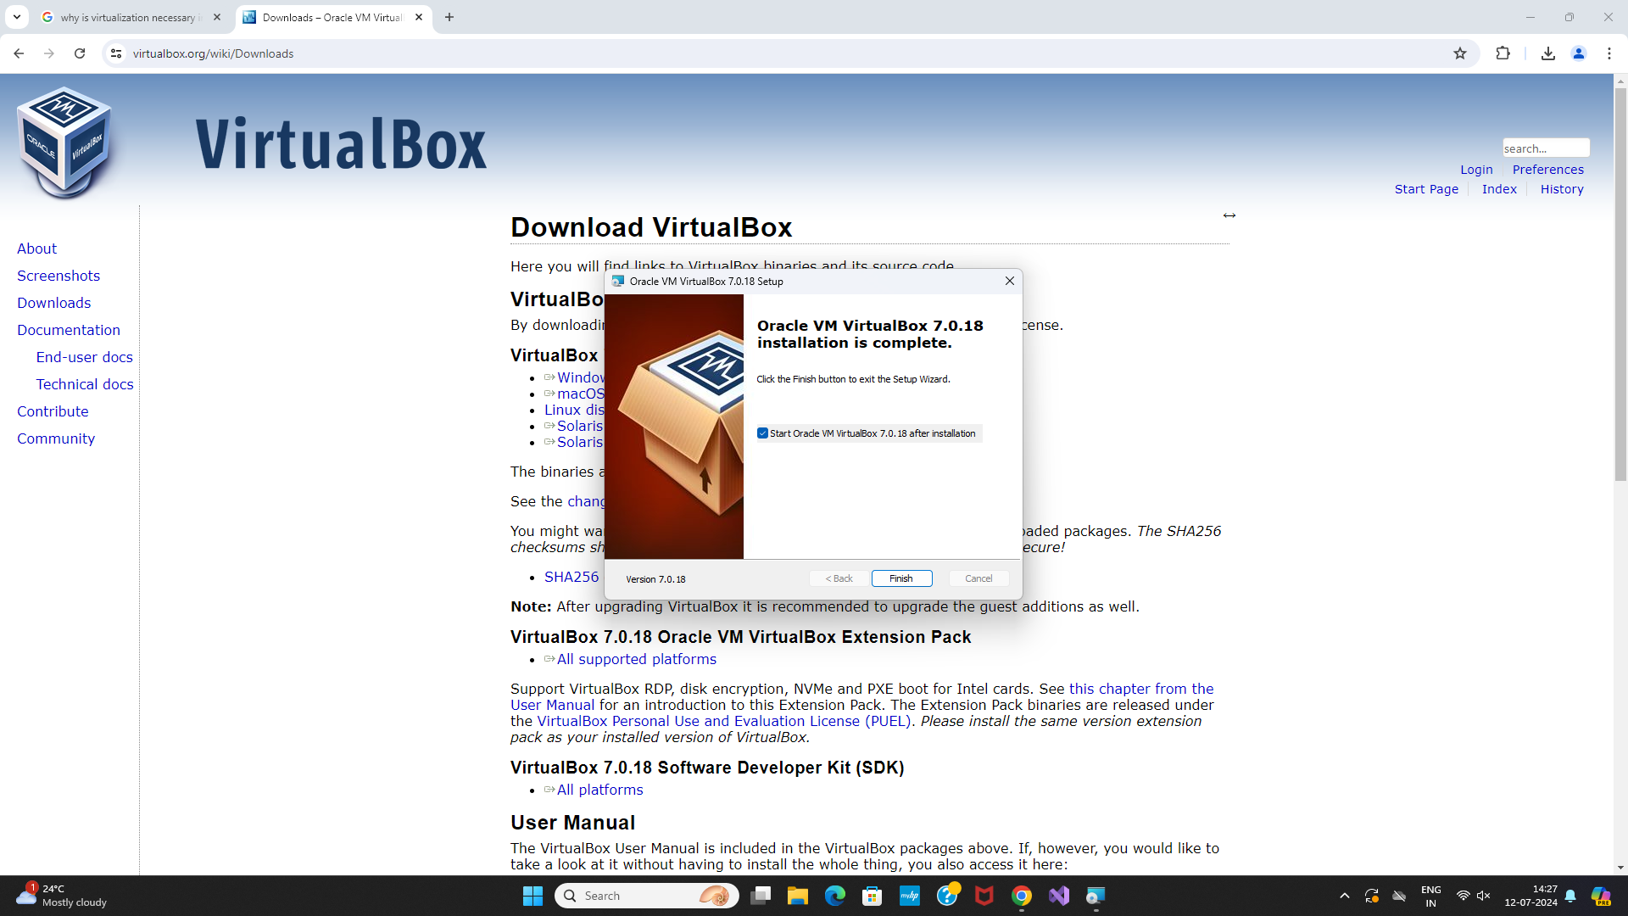

- Once the installation is complete. Click on “New” to add new OS on VM.
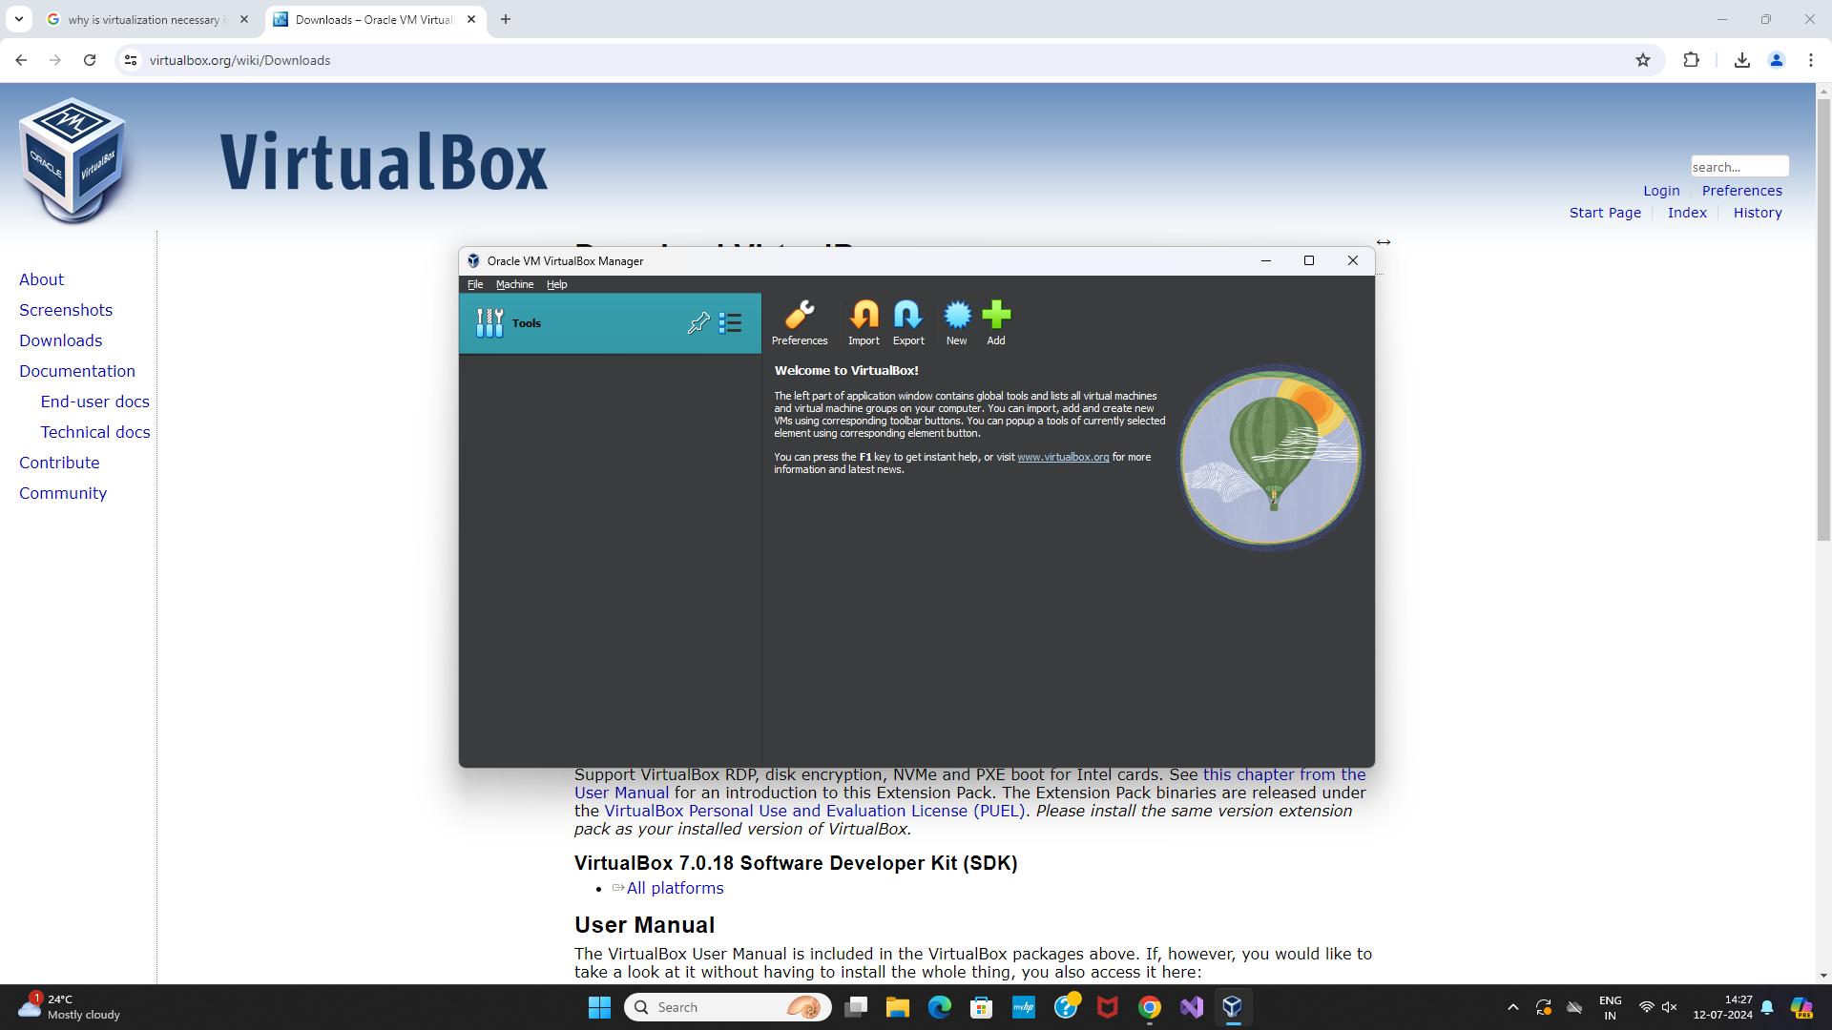

- On clicking New:
– Write the Name you want for your system, for example: Linux Mint 1
– Select Type: Linux.
– Select Version: Ubuntu.
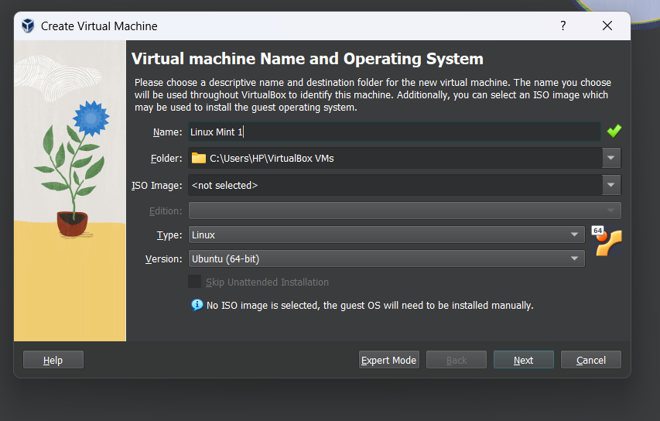

- Select the amount of RAM and Virtual disk.
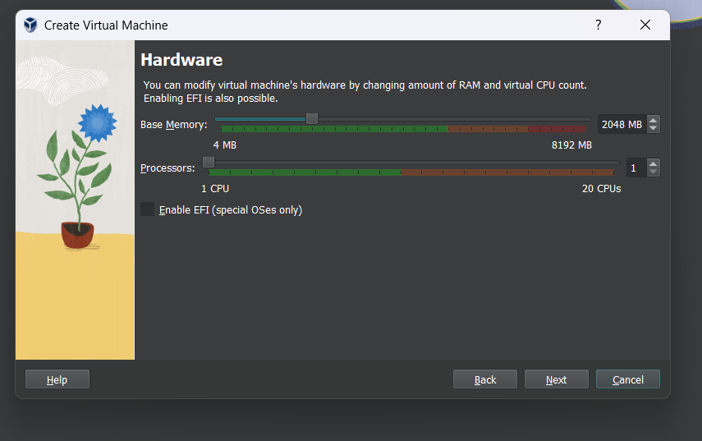
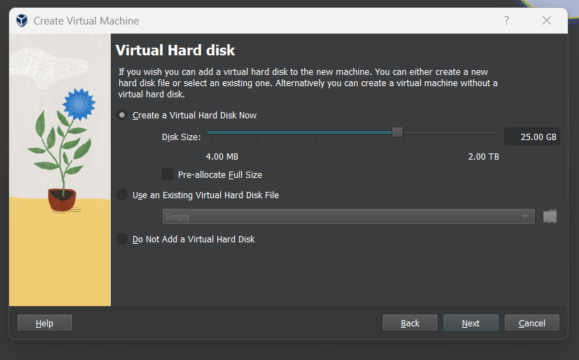

- Click Finish.
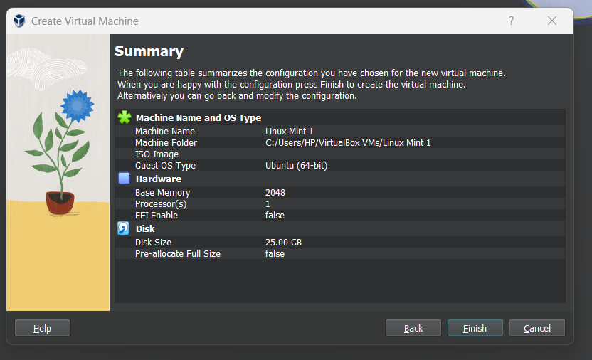

- Select the downloaded Linux ISO file :-
- Click on start to launch your system
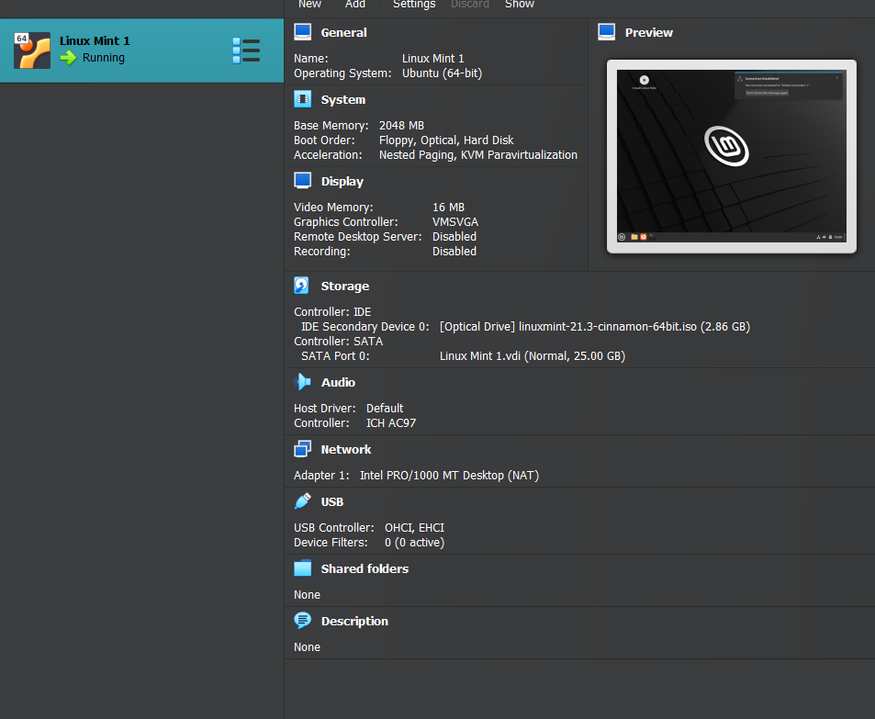

- Choose the iso file from your computer.
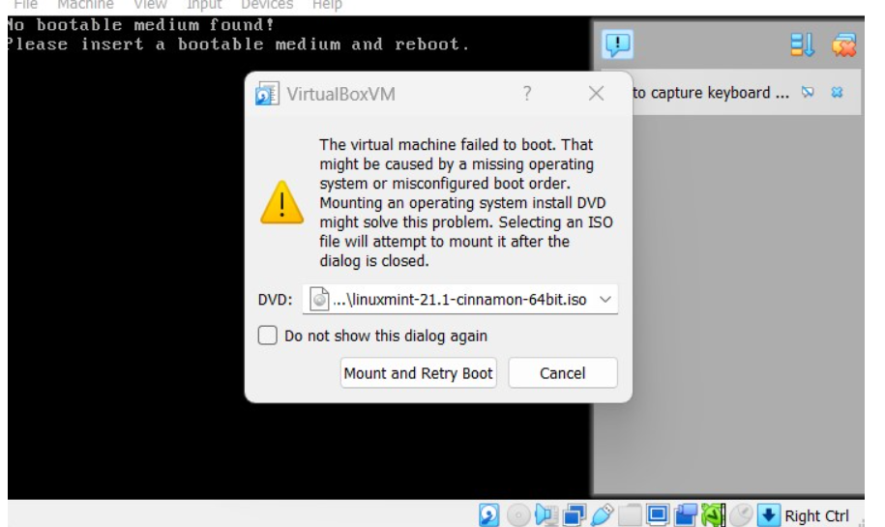

Click Mount and Retry Boot
- Install Linux – Click install Linux Mint
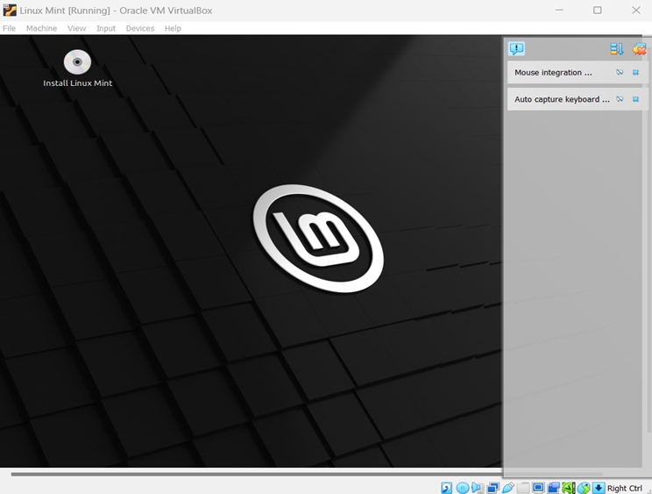
- Keep clicking continue . Then make your Account , click continue .
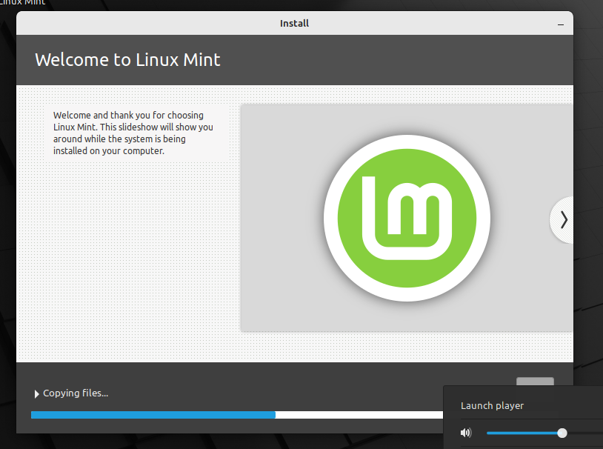
- Installation completed.
